TITLE OF THE PROJECT

Pre-Defined Email Generator

SYNOPSIS REPORT REVIEW - II

By-

Animesh Srivastava (RA1611003030250)

Udeshya Mittal (RA1611003030249)

Submitted to the Department of Computer Science and Engineering

in partial fulfillment of the requirements

for the degree of

Bachelor of Technology in

Computer Science and Engineering



SRM Institute of Science and Technology

April, 2018

**table of contents**

literature present system 3

proposed model 5

research 7

about the project 8

advantages of project 9

general methodology 10

research and analysis phase 12

design and development (flow chart) 13

coding phase homepage 14

suggestion webpage 15

email webpage 16

testing phase 18

evolution phase 19

reference 20

LITERATURE

Present System:

So we have decided to make this project because we think that there are many problems in present system.

As we know today if you want to register a complaint or want to give any feedback or suggestion then there are many problems in front of us.

First and the main problem is that we have to find a correct customer care number and when we have finally found a customer care number then we have to select our problem from a list of problems and then we can think that we can get solution of our problem.

But this is not the case. When we call a customer care number then sometimes our call is not even answered and by the time our call is answered many of us are frustrated. Then our call is transferred from one department to another and then we get our solution.

In this case also sometimes the customer care executive is not able to understand our problem and he is unable to give us sufficient solution for our problem, then they tell us to wait for their call and the procedure goes on like this.

So to save a person’s time by giving him another option for their complaint, suggestion and feedback we present our project pre-defined email generator.

In our project user can just come and enter his/her complaint and we will provide them with an email regarding that problem. This will help user in getting an instant response/solution for their problem.

We will also provide email for suggestion and feedback. In this case also we will provide email and user can enter his/her suggestion or feedback.

As we know nowadays email complaints get instant response. So to encourage this we provide you with pre-defined email generator. In this precious time of user is saved as he gets an email regarding his/her complaint and user also get instant response regarding their complaint.

In our project there will be no grammatical mistakes. Emails are very well written and fulfill user’s requirements.

If user want to edit something in our email then they can does that and send it.

Proposed Model:

Our aim is to make a predefined email generator. As we all know that online complaint have a much greater impact and they are basically in tend. As usually when we have some complaint or suggestion we are not able to contact customer care through call which is basically a major problem in India.

First of all we have to find a correct customer care number and when we have find a correct customer care number then first of all customer has to choose his problem from a list of options.

After choosing his problem from that list then he is able to contact to a customer care executive. To save our user precious time our project is predefined email generator.

In this we will provide you pre-generated email regarding your problems and you have to just edit your particulars like your name, phone number and then you can send that email.

In our project user will get variety of options regarding his/her complaint and emails according to that complaint and then user can send that email.

In our project user will not only get emails for their complaints but also for their suggestion and feedback.

The emails which we provide will be user friendly as the user as the person with minimum knowledge of computer can easily use our email.

The emails which we provide will have zero grammatical mistakes. Our website will also have email editing flexibility according to user. If user thinks that he/she has to edit something in our email as our email is not upto his requirements according to him in that case the user can edit email and change it according to him and then send it.

If you don’t find any option in our website according to your complaint in that case you can also give us suggestion about that and we will provide you with the email.

As you know you can edit email according to your needs in that case if you thinks that we should keep that change in that email then you can also suggest us about that and we will work on it.

Feedback option will also be provided in our email that If you want to give feedback to any service provider in that case you can give them feedback about any of their services.

We will also provide you with the exact email address of different companies or service providers like Indian railways, Airways, Telecommunication, School/college etc.

As nowadays email complaints will get instant response in comparison to other modes. So to encourage this we are coming with the project of pre-defined email.

In our website we will provide you with four different webpages in first webpage we will provide you that which option you want to choose.

In second webpage we will provide you with slides of different options regarding your complaint, suggestion or feedback.

When you choose a particular option of exactly what you need. Then you will get an email for that and you can edit your particulars in that and we will also provide you with email editing option to change your email according to your need and then in last webpage you can send that email.

Our website will provide you service without any charge that is totally free of cost.

RESEARCH:

We choose our project Pre Defined Email Generator Website as nowdays a common problem persist of not being able to communicate with costumer care as majorly in case of Paytm where refund of money still creates a major problem not only with it , People can need help anytime for any company whether food company etc for which they need to contact costumer care but most of the time it is not possible that at correct time the work is done.

May be its because of any communication gap, Costumer care number not available or invalid or not picking up phone by them or any problem can be there.

To avoid all this nowdays people use online platform like sending mails to company , tweet etc. which is beneficial for the person.

Then too people majorly do some mistake while typing mails to company , school , colleges etc it can be either grammatical or they don’t want to type the mail or they don’t have any idea how to express their problem or what is the format.

So to avoid all this and to encourage the use of online platform we decided to create a website which generally generates the email according to the problem or need of user . Not only the complaint email but also the emails about suggestion and complaint.

The benefits of our website are as there will be no grammatical errors, Format will be provided , user can edit the email according to there flexibility .

For developing the website we used Html , Css , Javascript and Dreamweaver and also took help from book like Html and Css the complete refrence and also online resources of tutorials present on Youtube.com , Wikipedia.com etc.

About the project:

Pre-Defined email generator is simply can say a template generator for the emails needed for the one . As until today there’s no such website which persist so we decided as our topic is pre-defined email generator which clearly tells about the email which is already defined for the user.

The pre-defined email generated website will be very much beneficial as it will be pre defined as the name denotes time saving , and most important there will be no grammatical mistakes as our website will be free of cost .

The website will work as according the user as needed like if the user need to send any complaint to a telecom company then on homepage of our website there will be three options –

* Suggestion
* Complaint
* Feedback

Then the user will click on the complaint option which will lead him to webpage for the one for which he/she has to send the mail regarding out of all the option the user will choose Telecom Companies then the email will be generated according to it and the user will now only need to add there name and additional details of them .

Also the user an edit the mail according to there flexibility, and suggest it to us.

Then the user can send the mail pre defined mail required and complete there task .

There will also be a suggestion complaint or feedback option for our website to like you want to send some suggestion , Complaint or feedback regarding us then you can send .

Advantages of the Project:

* Free of Cost Service - First of all our website will be free be use so that’s its easy to use for all and can be used by anyone.
* Ease in communication- By using our website there will be ease in communication to the customer care or any other school college etc as the mail is convenient.
* Avoidation of grammatical mistakes- There will be no grammatical mistakes present in the mail of the websites.
* User Friendly- The website is User friendly so all the options are clearly present and available for the user and the user doesn’t face any difficulty to use it.
* Email Editing Flexibility according to the user- The User can also hve email editing flexibility as if the user need to edit it he/she can and also suggest to us.
* Time Saving- By the Use of our website the user can have their time save and be fast for sending the mails with all the perfection.

General Methodology in developing the project:

We have divided our project in different phases and each phase has a deadline and every phase will fulfill a specific task. We have divided our project in different phases so that our project development will become easy.

We divided our project into following phases:

* Research and analysis phase
* Design and Development phase
* Coding phase
* Testing phase
* Evaluation phase

Research and analysis phase:

We will collect data and information required for our project from internet. We choose our project Pre Defined Email Generator Website as nowdays a common problem persist of not being able to communicate with costumer care as majorly in case of Paytm where refund of money still creates a major problem not only with it , People can need help anytime for any company whether food company etc for which they need to contact costumer care but most of the time it is not possible that at correct time the work is done.

May be its because of any communication gap, Costumer care number not available or invalid or not picking up phone by them or any problem can be there.

To avoid all this nowdays people use online platform like sending mails to company , tweet etc. which is beneficial for the person.

Then too people majorly do some mistake while typing mails to company , school , colleges etc it can be either grammatical or they don’t want to type the mail or they don’t have any idea how to express their problem or what is the format.

So to avoid all this and to encourage the use of online platform we decided to create a website which generally generates the email according to the problem or need of user . Not only the complaint email but also the emails about suggestion and complaint.

The benefits of our website are as there will be no grammatical errors, Format will be provided , user can edit the email according to there flexibility .

For developing the website we used Html , Css , Javascript and Dreamweaver and also took help from book like Html and Css the complete refrence and also online resources of tutorials present on Youtube.com , Wikipedia.com etc.

Design and development:

(FLOW CHART )

WEBSITE

SUGGESTION

FEEDBACK

COMPLAINT

RAILWAYS

HOSPITAL

TELECOM

AIRLINES

SCHOOL

COLLEGE

LEAVE FOR APPLICATION

SANITARY

CONDITION

NETWORK

PROBLEM

REFUND

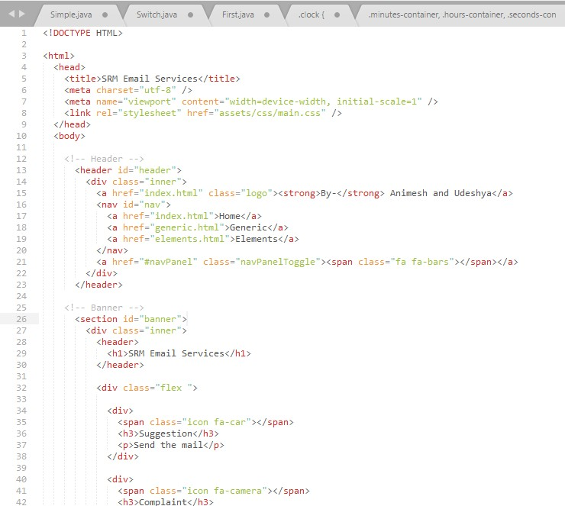Coding phase:

Homepage:

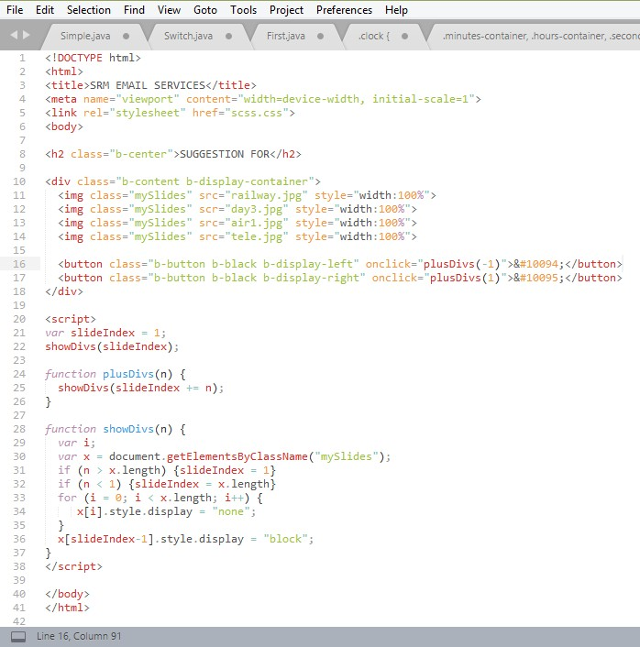Suggestion Slide (Same is of Feedback and Complaint):

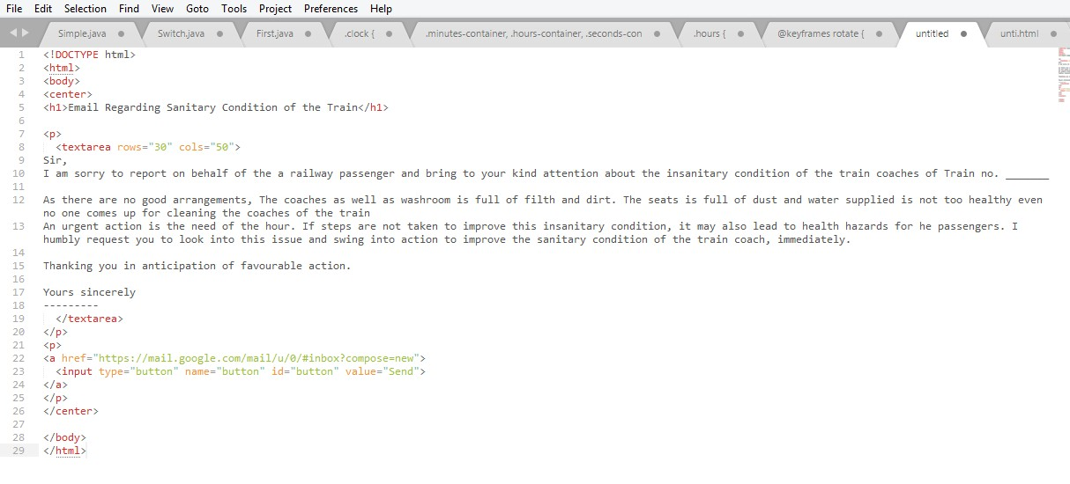Email webpage:

Testing phase:

This phase is one of the most important phase.

* After the successful compilation of each code we further check the code for any bug or lag.
* We are doing this phase so that we come to know that if there is any bug in our website and also to test that if our website is working smoothly or not.
* Website should be lag less.
* We have tested this website on different browsers and also in incognito mode and in all the browsers our website is working properly.
* We have also tested website is light or not.
* It can handle much of the trafficking. So that it doesn’t lag when very much people surf on our website.
* Also checked that the website is user friendly.
* Website content should be good and free of grammatical mistakes.
* We have tested that all the animations that we have added are working smoothly.
* After success of this phase our website is ready to be used.

Evaluation phase:

In this phase we will evaluate the project develop after testing phase. This phase is also one of the most important phase.

These are the following parameters to evaluate our website:

* Evaluate whether the website is secure or not.
* Webpage is light and hence the loading time is less.
* Evaluation of user interface.
* Evaluation of compatibility for different devices.
* Adapted to phone layout.
* Animations added are fast.
* No popups.
* Ad free.
* No premium content.
* Website can even load up within few second even on 2G speeds.

REFRENCES:

* https://www.tutorialspoint.com
* https://en.wikipedia.org/wiki/JavaScript
* https://www.w3schools.com/html/
* https://www.youtube.com/watch?v=k3dJKtQmyd0
* https://www.youtube.com/watch?v=ctI1XUjueaE
* https://www.youtube.com/watch?v=nKf8OVyXvrg